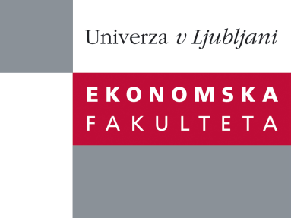

Raziskovalni center Ekonomske fakultete
organizira znanstveno - raziskovalni seminar,
ki bo v četrtek, 07. Junija 2012, ob 12:00 uri
v P-109 na Ekonomski fakulteti v Ljubljani.

Predstavljen bo članek:

“Doing What you Love, Loving What You Do: Jobs, Careers and Callings”

avtor: Prof. dr. A.R. Elangovan (Director, International Programs, Gustavson School of Business, University of Victoria )

˝Current literature on careers, social identity and meaning in work tends to understate the multiplicity, historical significance, and nuances of the concept of calling(s). In this research, we trace the evolution of the concept from its religious roots into secular realms and develop a typology of interpretations using occupation and religious orientation as core dimensions. We offer a definition of calling that emphasizes action, a convergence of selves, and a pro-social intention. Next, we identify a number of key conditions necessary for discovering a calling, explore the relevance of callings to a range of organizational behaviour phenomena, and offer suggestions for future research.˝

Na brezplačni seminar se lahko prijavite v Službi za znanstveno raziskovalno delo, po telefonu (01) 58-92-490, ali po e-pošti research.seminars@ef.uni-lj.si, in sicer do srede, 06.06.2012.

Vljudno vabljeni!

