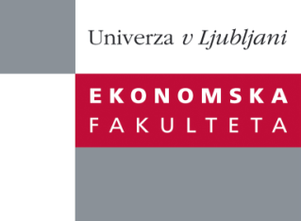

Raziskovalni center Ekonomske fakultete
organizira znanstveno - raziskovalni seminar,
ki bo v sredo, 19. Junija 2013, ob 12:00 uri
v P-109 na Ekonomski fakulteti v Ljubljani.

Predstavljen bo članek:

“Action Based Learning for Millenials: Using Design Thinking to Improve Entrepreneurship Education”

Avtorji: asist. mag. Blaž Zupan, Ekonomska fakulteta, Univerza v Ljubljani (soavtorji: doc. dr. Anja Svetina Nabergoj, asist. mag. Rok Stritar, izr. prof. dr. Mateja Drnovšek, Ekonomska fakulteta, Univerza v Ljubljani)
˝ This chapter showcases the effects of integrating design thinking to improve entrepreneurship education within a business school. We clearly illustrate what skills Design thinking enhances and what mindsets it develops through intensive problem-based pedagogy. Design thinking as a teaching tool allows for a high degree of experimentation and can be used as a teaching resource in business as well as numerous other educational contexts. We argue that by using Design thinking as a teaching tool business teachers can successfully confront traditional and more recent challenges of business education, such as enhancing creativity, obtaining practical skills, multi-disciplinary problem solving and action-based learning. ˝

Na brezplačni seminar se lahko prijavite v Službi za znanstveno raziskovalno delo, po telefonu (01) 58-92-490 ali po e-pošti research.seminars@ef.uni-lj.si, do torka, 18.06.2013.

Vljudno vabljeni!

