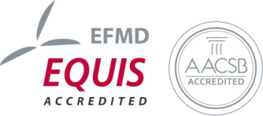
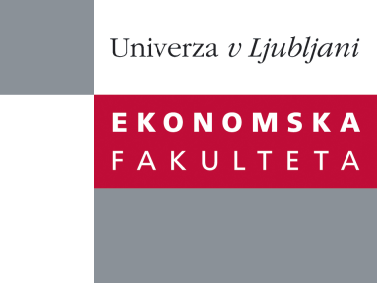

Raziskovalni center Ekonomske fakultete
organizira znanstveno - raziskovalni seminar,
ki bo v četrtek, 14. Junija 2012 ob 12:00 uri
v P-109 na Ekonomski fakulteti v Ljubljani.

Predstavljen bo članek:

˝Spillovers from services FDI to manufacturing firms in new EU member states˝

avtor: Philipp Marek, Halle Institue for Economic Research (IWH)
Department Structural Economics; Faculty of Economics, University of Ljubljana

˝Spillovers from foreign affiliates to local firms is one of the main FDI related research and policy issues. At the same time, services dominate inward FDI in general and in the new EU member states (NMS) in particular. At end 2009, services accounted for 67.5% of total inward FDI stock in NMS-10. There are two basic reasons for hypothesizing positive spillovers from services FDI to manufacturing. The first is theoretical proposition that benefits of foreign affiliates' superior technologies and organizational skills may spill over to domestic firms. The overwhelming conclusion of the empirical studies is that vertical inter-industry spillovers (such as Spillovers from services FDI to manufacturing) are more likely to take place than horizontal ones. The second reason is a distinctive role played by services as inputs in the production of goods and other services. It is generally recognised and empirically evidenced that services have important impact on growth and productivity of other sectors, most notably of the manufacturing sector. Underdeveloped services sectors were distinctive socialist legacy of NMS-10 and one of basic obstacles to their faster growth and development. The transition process has brought distinctive liberalization of services in NMS-10.˝

Na brezplačni seminar se lahko prijavite v Službi za znanstveno raziskovalno delo, po telefonu (01) 58-92-490, ali po e-pošti research.seminars@ef.uni-lj.si, do srede 13.06.2012.

Vljudno vabljeni!

