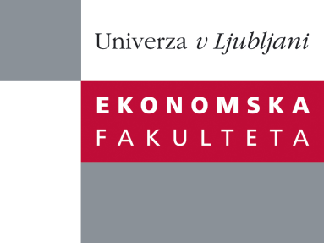

Raziskovalni center Ekonomske fakultete
organizira znanstveno - raziskovalni seminar,
ki bo v četrtek 17. aprila 2014, ob 12:00 uri
v P-109 na Ekonomski fakulteti v Ljubljani.

Predstavljen bo članek:

“Differences in the Inclusion and Treatment of Terminology in OALD3, OALD4 and OALD8 “

avtor: doc. dr. Alenka Vrbinc, Ekonomska fakulteta, Univerza v Ljubljani

”This contribution deals with the inclusion and treatment of scientific and technical vocabulary in the third, fourth and eighth editions of Oxford Advanced Learner's Dictionary. The comparison of these editions is based on a random sample of 50 pages from OALD8 from the lemma foot to gimmick. The same lemma range was also studied in OALD3 and OALD4. First, different ways of indicating terminology were identified: i.e., subject-field labels, definitions and short cuts. Then all the lemmata or their senses marked with a subject-field label were found and a list of all subject-field labels used in this lemma range was compiled to see similarities and differences between individual editions. The comparison showed that the number of subject-field labels in all three editions is almost identical, but the subject-field labels differ from edition to edition. The issue of overly specific labels (e.g., 'anatomy', 'phonetics') and labels that are too broad (e.g., 'science', 'technical') is addressed. The next part is devoted to the changes in the treatment of LSP lexical items in these three editions of OALD, from missing labels to changes in labels and ways of indicating terminology by means of definitions and/or short cuts. The conclusion suggests improvements in the subject-field labels themselves, a more consistent way of including subject-field labels even when the definitions indicate the subject field and an improved use of short cuts when the reference is to a certain subject field.”

Na brezplačni seminar se lahko prijavite v Službi za znanstveno raziskovalno delo, po telefonu (01) 58-92-490, ali po e-pošti research.seminars@ef.uni-lj.si, in sicer do srede, 16.4.2014
Vljudno vabljeni!

