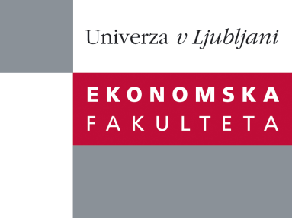

Raziskovalni center Ekonomske fakultete
organizira znanstveno - raziskovalni seminar,
ki bo v sredo, 05. Septembra 2012 ob 12:00 uri
v P-109 na Ekonomski fakulteti v Ljubljani.

Predstavljen bo članek:

˝Sovereign Credit Risk and Government Effectiveness˝

avtor: doc. dr. Alexandre Jeanneret, HEC Montréal, Kanada (soavtor: Jean-Claude Cosset, HEC Montréal)

This paper investigates how a country’s governance, measured by the level of government effectiveness, affects its sovereign credit risk. We develop a structural model for sovereign credit risk in which the government adjusts its default policy to the level of governance in place. Poor governance is associated with the government’s ability to divert fiscal revenues for socially inefficient usage, rather than using these funds to service its debt. Better governed countries are predicted to exhibit lower incentives to default and thus benefit from a narrower sovereign credit spread. Moreover, the effect of government effectiveness on sovereign credit risk is highly non-linear; the relationship strengthens with default risk, indebtedness, and a deterioration in economic conditions. Using a sample of 88 developed and emerging countries over the period 1996-2010, we provide strong empirical support for the model’s predictions.

Na brezplačni seminar se lahko prijavite v Službi za znanstveno raziskovalno delo, po telefonu (01) 58-92-490, ali po e-pošti research.seminars@ef.uni-lj.si, do torka 04.09.2012.

Vljudno vabljeni!

