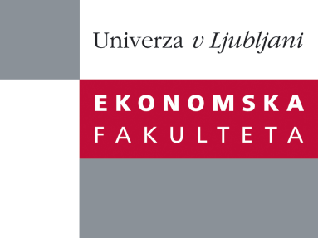

Raziskovalni center Ekonomske fakultete
organizira znanstveno - raziskovalni seminar,
ki bo v torek 12. Junija 2012, ob 12:00 uri
v P-109 na Ekonomski fakulteti v Ljubljani.

Predstavljen bo članek:

“Business strategy and performance of horizontal acquisitions˝

avtor: izr. prof. dr. Matej Lahovnik, Faculty of Economics, University of Ljubljana

˝ The aim of this paper is to examine the factors that influenced the performance of horizontal acquisitions in the Slovenian economy in transition. Our research is focused on the relationship between companies involved in an acquisition. We examined the performance of horizontal acquisitions regarding the strategic fit between the business strategies of acquiring and acquired companies in the post-acquisition period. Horizontal acquisitions in which the acquiring and acquired companies developed an identical type of business strategy in the post-acquisition period outperformed acquisitions where the acquiring and acquired companies developed different types of a generic business strategy. The results suggest that the sharing of activities and transfer of skills are important in cases of a fit between business strategies in the post-acquisition period, whereas they do not play an important role in cases where the acquirer and acquired company pursue different types of business strategies. ˝

Na brezplačni seminar se lahko prijavite v Službi za znanstveno raziskovalno delo, po telefonu (01) 58-92-490, ali po e-pošti research.seminars@ef.uni-lj.si
Vljudno vabljeni!

