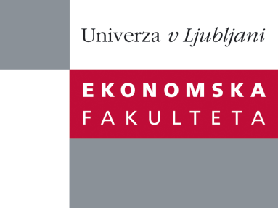

Raziskovalni center Ekonomske fakultete
organizira znanstveno - raziskovalni seminar,
ki bo v sredo, 13. Junija 2012, ob 12:00 uri
v P-109 na Ekonomski fakulteti v Ljubljani.

Predstavljen bo članek:

“Internationalization and Performance of Retail Firms: A Bayesian Dynamic Model”
avtor: doc. dr. Albert Assaf (Isenberg School of Management, University of Massachusetts)

˝The study offers a fresh approach to the literature examining the effect of internationalization on retail-firm performance. It draws on the organizational learning theory to test the moderating effect of four variables which are hypothesized to affect the performance of internationalizing retailers through facilitating the transfer of learning in international markets. The study innovates by introducing a new performance metric, and an advanced methodology to account for the dynamic aspects of organizational learning. Testing the hypotheses on a sample of international retailers, the authors find that the relationship between internationalization and performance is U-shaped, and moderated by mergers and acquisitions, age at entry to international markets and country of origin. The findings extend prior research by providing more comprehensive evidence regarding the conditions under which internationalization leads to improved performance. The authors conclude by outlining the implications for practice.˝

Na brezplačni seminar se lahko prijavite v Službi za znanstveno raziskovalno delo, po telefonu (01) 58-92-490, ali po e-pošti research.seminars@ef.uni-lj.si, in sicer do torka, 12.06.2012.
Vljudno vabljeni!

