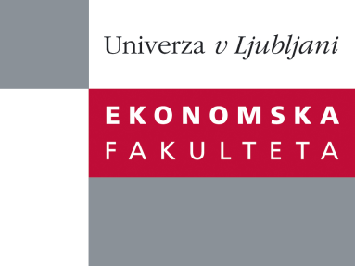

Raziskovalni center Ekonomske fakultete
organizira znanstveno - raziskovalni seminar,
ki bo v sredo, 19. Septembra 2012 ob 12:00 uri
v P-109 na Ekonomski fakulteti v Ljubljani.

Predstavljen bo članek:

˝Dividend-protected convertible bonds and the disappearance of call delay˝

avtor: dr. Patrick Verwijmeren, VU, Amsterdam (skupaj z Bruce D. Grundy, University of Melbourne)

Firms have not historically called their convertible bonds as soon as they could force conversion. Various explanations for the delay rely on the size of the dividends that bondholders forgo so long as they do not convert. We investigate an important change in convertible security design, namely that more than 95 percent of recent convertible bond issues are dividend-protected. Dividend protection means that the conversion value of the shares into which a bond is convertible is unaffected by dividend payments and dividend related rationales for call delay become moot. We document that dividend-protected convertibles are called as soon as conversion can be forced.

Na brezplačni seminar se lahko prijavite v Službi za znanstveno raziskovalno delo, po telefonu (01) 58-92-490, ali po e-pošti research.seminars@ef.uni-lj.si, do torka 18.09.2012.

Vljudno vabljeni!

