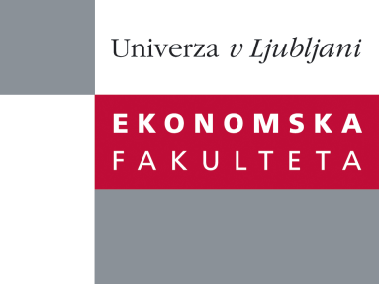

Raziskovalni center Ekonomske fakultete
organizira znanstveno - raziskovalni seminar,
ki bo v torek, 18. oktobra 2011, ob 16:00 uri
v P-201 na Ekonomski fakulteti v Ljubljani.

Dr. Egon Zakrajšek

(Federal Reserve Board, ZDA)

bo predstavil članek:

“Interest Rate Risk and Bank Equity Valuations”

"Because they engage in maturity transformation, a steepening of the yield curve should, ceteris paribus, boost bank profitability. We re-examine this conventional wisdom by estimating the reaction of bank intraday stock returns to exogenous fluctuations in interest rates induced by monetary policy actions. We construct a new measure of the mismatch between the repricing or maturity time of bank assets and those of bank liabilities and examine how the reaction of stock returns varies with the size of this maturity gap and other bank characteristics. Our results indicate that bank stock prices decline significantly in response to an unanticipated increase in the general level of interest rates and the steepening of the yield curve. Consistent with their roles as maturity transformers, a large maturity gap significantly attenuates the negative reaction of stock prices to an unexpected steepening of the yield curve. Increased intensity of the usage of interest rate derivatives further mitigates the negative reaction of stock returns to such a slope surprise. The results using accounting measures of profitability point to the importance of adjustments in quantities—as well as interest margins—for understanding the reaction of bank equity valuations to interest rate surprises."
Na brezplačni seminar se lahko prijavite v pisarni RCEF, po telefonu (01) 58-92-490, ali po e-pošti na naslov sodelavec.rcef@ef.uni-lj.si do ponedeljka, 17.10.2011.
Vljudno vabljeni!

