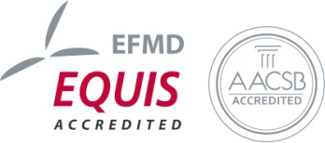
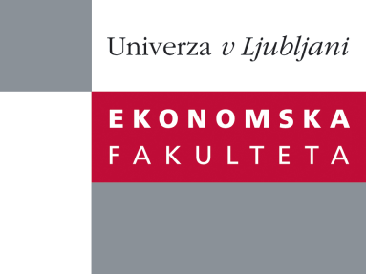

Raziskovalni center Ekonomske fakultete
organizira znanstveno - raziskovalni seminar,
ki bo v četrtek, 20. oktobra 2011, ob 12:00 uri
v P-109 na Ekonomski fakulteti v Ljubljani.

Prof.dr. Marko Pahor

(Univerza v Ljubljani, Ekonomska fakulteta)

bo predstavil članek:

“Family-friendly workplace: the analysis of organisational effects”

We propose and test a model of the relationships between family friendly practices and its effects at the organisational level. We investigate in more detail the impact of introducing eight groups of family friendly practices on a set of indicators including among others improved retention rate, motivation of employees, efficiency, organizational climate, motivation, work-life balance of employees and employee satisfaction.We analyse data from 2005 to 2010. Empirical data was collected through a survey of Slovenian companies that have acquired the Family-Friendly Company certificate. We test the regression model, with improvement index as dependent variable. We test how the perceived improvement due to introduction of family friendly practices depends on the characteristics of the company and the number of family friendly practices adopted by the company.
The most important finding of the study is that companies with a larger share of men in the workforce benefit most from introducing the family-friendly practices. The study also shows that employers with greater commitment to support practices to reconcile work and family are introducing a larger number of family-friendly measures and experience more positive effects. Characteristics of the company play an important role in the extent to which the positive effects are manifested.
Na brezplačni seminar se lahko prijavite v pisarni RCEF, po telefonu (01) 58-92-490, ali po e-pošti na naslov sodelavec.rcef@ef.uni-lj.si do srede, 19.10.2011.
Vljudno vabljeni!

