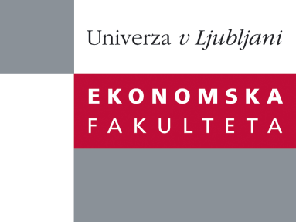

# Raziskovalni center Ekonomske fakultete

organizira znanstveno - raziskovalni seminar,

ki bo v **sredo, 04. Julija 2012,** ob **12:00 uri**

v **P-109** na **Ekonomski fakulteti v Ljubljani.**

Predstavljen bo članek:

**“Automatic Derivation of Service Candidates from Business Process Model Repositories”**

*avtor: prof. dr. Jan Mendling (Wirtschaftsuniversität Wien, Austria)*

˝Although several approaches for service identification have been defined in research and practice, there is a notable lack of automatic analysis techniques. In this talk we take the integrated approach by Kohlborn et al. as a starting point, and combine different analysis techniques in an novel way. Our contribution is an automated approach for the identification and detailing of service candidates. Its output is meant to provide a transparent basis for making decisions about which services to implement with which priority. The approach has been implemented and evaluated for an industry collection of process models.˝

***O predavatelju:*** Prof. Dr. Jan Mendling is a Full Professor and head of the Institute for Information Business at Wirtschaftsuniversität Wien (WU Vienna), Austria. His research areas include Business Process Management, Conceptual Modelling and Enterprise Systems. He has published more than 150 research papers and articles, among others in ACM Transactions on Software Engineering and Methodology, IEEE Transaction on Software Engineering, Information Systems, Data & Knowledge Engineering, and Decision Support Systems. He is member of the editorial board of three international journals, one of the founders of the Berlin BPM Community of Practice (<<<http://www.bpmb.de>>>), organizer of several academic events on process management, and member of the IEEE Task Force on Process Mining. His Ph.D. thesis has won the Heinz-Zemanek-Award of the Austrian Computer Society and the German Targion-Award for dissertations in the area of strategic information management.

Na brezplačni seminar se lahko prijavite v Službi za znanstveno raziskovalno delo, po telefonu (01) 58-92-490 ali po e-pošti [research.seminars@ef.uni-lj.si](mailto:research.seminars@ef.uni-lj.si), do torka, 03.07.2012.

**Vljudno vabljeni!**