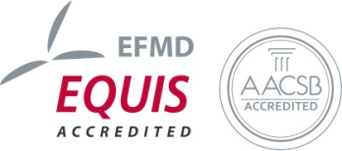
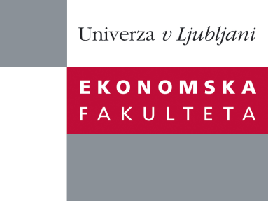

Raziskovalni center Ekonomske fakultete
organizira znanstveno - raziskovalni seminar,
ki bo v ponedeljek, 15. Oktobra 2012, ob 12:00 uri
v P-108 na Ekonomski fakulteti v Ljubljani.

Predstavljen bo članek:

˝Grocery Bag Bans and Foodborne Illness˝

avtorja: prof. dr. Jonathan Klick, University of Pennsylvania, Erasmus University Rotterdam and Yale University, in Joshua D. Wright, George Mason University, School of Economics

“Recently, many jurisdictions have implemented bans or imposed taxes upon plastic grocery bags on environmental grounds. Plastic bags are thought to endanger marine animals and add to litter. San Francisco County was the first major US jurisdiction to enact such a regulation, implementing a ban in 2007 and extending it to all retailers in 2012. There is evidence, however, that reusable grocery bags, a common substitute for plastic bags, contain potentially harmful bacteria, especially coliform bacteria such as E. coli. We examine emergency room admissions related to these bacteria in the wake of
the San Francisco ban. We find that ER visits spiked as soon as the ban went into effect. Relative to other counties, ER admissions in San Francisco County increase by at least one fourth, and deaths from these infections exhibit a similar increase.˝

Na brezplačni seminar se lahko prijavite v Službi za znanstveno raziskovalno delo, po telefonu (01) 58-92-490, ali po e-pošti research.seminars@ef.uni-lj.si, in sicer do petka,12.10.2012.

Vljudno vabljeni!

