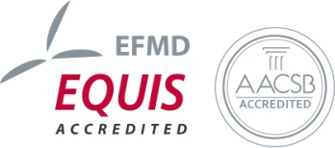
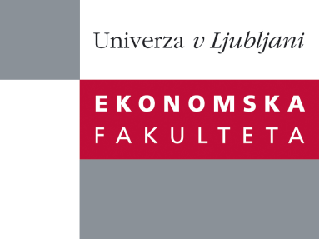
Research Centre, Faculty of Economics
is organizing a scientific - research seminar
on Wednesday, 17th October 2012, at 12:00 pm
in the room P-109 at the Faculty of Economics Ljubljana.

Presentation of an article:
˝ International migration, human capital formation, and saving˝
author: Oded Stark, Full Professor, Distinguished Fellow, University of Bonn, University Professor, University of Klagenfurt, (Adjunct Professor, University of Tuebingen, Honorary University Professor, University of Vienna, Distinguished Professor, Warsaw University, Distinguished Professor, Warsaw School of Economics, Presidential Professor of Economic Sciences (Poland))

In a two-period model with no option of saving, optimizing individuals in a developing country will forfeit part of their work-time in the first period of their life in order to acquire human capital that will increase their earnings in the second period of their life. Stark et al. (1997, 1998) showed that when the prospect of migrating to a developed country increases the expected returns to human capital, individuals acquire more human capital. When saving becomes an option, viewed as an alternative way of raising second-period income, will the prospect of migrating have the same effect on human capital formation? We show that the option of saving does not negate the positive impact of the chance to work abroad on the formation of human capital in the home country. In particular, if the individuals’ utility functions remain as in Stark et al. (1998), the prospect of migrating leads to increased investment in human capital. Moreover, if when migration is possible individuals opt to save, then the investment in human capital is greater than when migration is not possible, even though the individuals’ utility functions do not fulfill the particular conditions imposed in Stark et al. (1998). Somewhat surprisingly, the magnitude of the effect of the prospect of migrating on human capital formation can even be greater when saving is an option than when it is not.

You can register for the free seminar by phone (01) 58-92-490, or via e-mail: research.seminars@ef.uni-lj.si until Tuesday, 16.10.2012.

Welcome!

