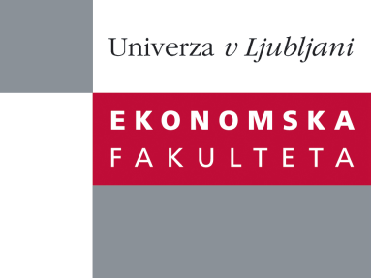

Raziskovalni center Ekonomske fakultete
organizira znanstveno - raziskovalni seminar,
ki bo v sredo, 21. Maja 2014, ob 13:00 uri
v P-109 na Ekonomski fakulteti v Ljubljani.

Predstavljen bo članek:

“Optimizing a research strategy”

avtor: prof. Brian Lucey, Trinity College, Dublin, Irska

“Where should you publish? When? With whom? What about coauthors? What matters most - journal ranking or your preference. Do conferences matter?
Professor Brian Lucey has published over 90 articles in per reviewed international journals as well as a number of books and textbooks. He sits on numerous editorial boards and edits two journals published by Elsevier. ​In this talk he will address how a scholar should optimise their publication strategy, and give his views on publications and publishing. The short talk will be followed by questions and, maybe, answers...”

Na brezplačni seminar se lahko prijavite v Službi za znanstveno raziskovalno delo, po telefonu (01) 58-92-490, ali po e-pošti research.seminars@ef.uni-lj.si, in sicer do torka, 20.05.2014.

Vljudno vabljeni!

