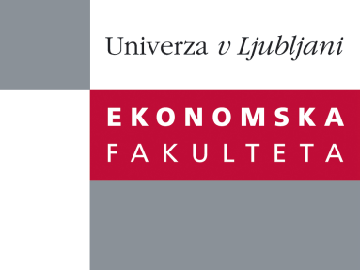

Raziskovalni center Ekonomske fakultete
organizira znanstveno - raziskovalni seminar,
ki bo v četrtek, 27. Septembra 2012, ob 12:00 uri
v P-109 na Ekonomski fakulteti v Ljubljani.

Predstavljen bo članek:

“Towards business intelligence systems success: Effects of maturity and culture on analytical decision making”

avtor: doc.dr. Aleš Popovič (Univerza v Ljubljani, Ekonomska fakulteta)
˝The information systems (IS) literature has long emphasized the positive impact of information provided by business intelligence systems (BIS) on decision-making, particularly when organizations operate in highly competitive environments. Evaluating the effectiveness of BIS is vital to our understanding of the value and efficacy of management actions and investments. Yet, while IS success has been well-researched, our understanding of how BIS dimensions are interrelated and how they affect BIS use is limited. In response, we conduct a quantitative survey-based study to examine the relationships between maturity, information quality, analytical decision-making culture, and the use of information for decision-making as significant elements of the success of BIS. Statistical analysis of data collected from 181 medium and large organizations is combined with the use of descriptive statistics and structural equation modeling. Empirical results link BIS maturity to two segments of information quality, namely content and access quality. We therefore propose a model that contributes to understanding of the interrelationships between BIS success dimensions. Specifically, we find that BIS maturity has a stronger impact on information access quality. In addition, only information content quality is relevant for the use of information while the impact of the information access quality is non-significant. We find that an analytical decision-making culture necessarily improves the use of information but it may suppress the direct impact of the quality of the information content.˝

Na brezplačni seminar se lahko prijavite v Službi za znanstveno raziskovalno delo, po telefonu (01) 58-92-490 ali po e-pošti research.seminars@ef.uni-lj.si, do srede, 26.09.2012.
Vljudno vabljeni!

