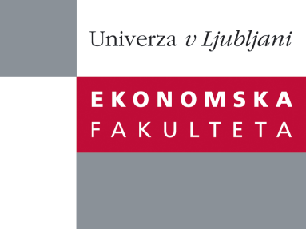
Research Centre, Faculty of Economics
is organizing a scientific - research seminar
on Wednesday, 24th October 2012, at 12:00 pm
in the room P-109 at the Faculty of Economics Ljubljana.

Presentation of an article:
˝ ˝Climate Change, and Social Instability：Some Empirical Evidences from Chinese Economic History˝

author: Hongjun Zhao (School of International Economics and Trade
Shanghai Institute of Foreign Trade)

Based on paleo-climate reconstruction data on temperature, historical records on the frequency of natural disaster, rice price, population and the frequency of social instability in China over the past 2000 years, this paper tests the correlation between climate change and social instability in Chinese history. It finds that a higher temperature over the mean, reduces the level of social instability, while a lower temperature change down to the mean raises the level of social instability, no matter whichever dimension of the frequency of social instability is used to be the proxy. The impact of Snow anomaly is structural, positive on the frequency of foreign invasion and other undefined disorder, while negative on the frequency of domestic disorder. Within our control variables, this paper also finds something interesting, for example, the commonsense of the positive impact of natural disaster on social instability may not be completely correct, depending on which kind of social instability we discuss. Certainly, facing such a very complicated project, more interdisciplinary, empirical studies are needed.

You can register for the free seminar by phone (01) 58-92-490, or via e-mail: research.seminars@ef.uni-lj.si until Tuesday, 23.10.2012.

Welcome!

