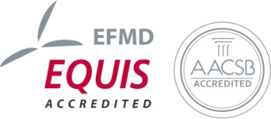
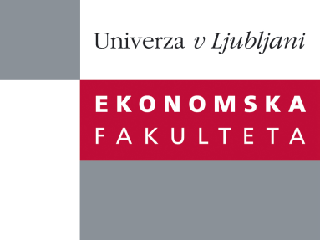

Raziskovalni center Ekonomske fakultete
organizira znanstveno - raziskovalni seminar,
ki bo v torek, 22. Aprila 2014, ob 12:00 uri
v P-109 na Ekonomski fakulteti v Ljubljani.

Predstavljen bo članek:

“RENEWING THE RESOURCE BASE AS A KEY TO SUSTAINED COMPETITIVE ADVANTAGE IN THE IT INDUSTRY: A DYNAMIC CAPABILITIES FRAMEWORK”

avtor: asist. dr. Lidija Breznik, Ekonomska fakulteta, Univerza v Ljubljani

˝ The overall purpose of this research is to indicate that firms which renew their resource base upon dynamic capability approach can generate and sustain competitive advantage. This purpose takes two main tracks. First, it identifies relevant capabilities in IT firms in general and from a dynamic capability composition of sense, seize and reconfiguring capabilities. Second, this paper investigates the level of deployment of each individual dynamic capability, and links this to firm performance. In order to investigate the relationships involved, in-depth interviews were conducted in six representative IT firms. The results indicate that firms with stronger commitment to dynamic capabilities deployment are more successful and hold the potential of sustained competitive advantage. We also found that innovation capability, managerial capability and human resource capability are the most relevant capabilities that allow firms to successfully adapting to changing environment and high demanding IT market. This research contributes to the dynamic capability literature by providing empirical support to better understand the embedded nature of dynamic capabilities. From practitioners' point of view, the main premise of dynamic capability view of constantly searching inside and outside firm's boundaries, recognizing opportunities and exploiting them can be a winning future strategy orientation.˝

Na brezplačni seminar se lahko prijavite v Službi za znanstveno raziskovalno delo, po telefonu (01) 58-92-490, ali po e-pošti research.seminars@ef.uni-lj.si, in sicer do ponedeljka, 21.4.2014.
Vljudno vabljeni!

