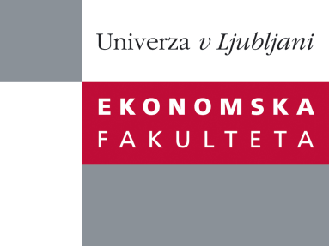

Raziskovalni center Ekonomske fakultete
organizira znanstveno - raziskovalni seminar,
ki bo v sredo, 28. November 2012, ob 12:00 uri
v P-109 na Ekonomski fakulteti v Ljubljani.

Predstavljen bo članek:

˝Why and How Do Banks Lay off Credit Risk? The Choice between Loan Sales and Credit Default Swaps˝

avtorica: prof. dr. Nadia Massoud, (Schulich School of Business at York University)

This paper investigates why banks use different credit risk transfer (CRT) instruments to hedge the credit risk of syndicated loans. We examine banks’ decisions to insure, sell, or continue to hold loans by considering specific characteristics of both lenders and borrowers. We find that loans to borrowers with low credit quality are more likely to be sold in the secondary loan market, but loans to borrowers with high credit quality are more likely to be hedged using credit default swaps (CDS), especially when the lenders face binding financial or regulatory constraints, which is consistent with the predictions of the theoretical literature. Interestingly, we find that bank lenders are more likely to use CDS as a hedge instrument for relatively good-quality borrowers if monitoring costs are relatively high. Finally, our results show that reputable lenders are less likely to use CRT instruments for loans with high-quality borrowers.

O avtorici: Dr. Nadia Massoud is an Associate Professor of Finance at the Schulich School of Business, York University in Toronto. Massoud earned her Ph.D. from Queen’s University and her Master of Economics from the Waterloo University. Massoud has extensively conducted researched in the areas of Financial Intermediation, Corporate Finance, Corporate Governance and Market Microstructure. She has published in major academic journals such as the Review of Financial Studies, Journal of Finance, Journal of Financial and Quantitative Analysis and Rand Journal of Economics. Her research has won several prestigious awards and grants including Social Sciences and Humanities Research Council, SSHRC, Canada.

Na brezplačni seminar se lahko prijavite v Službi za znanstveno raziskovalno delo, po telefonu (01) 58-92-490, ali po e-pošti research.seminars@ef.uni-lj.si, in sicer do torka, 27.11.2012.

Vljudno vabljeni!

