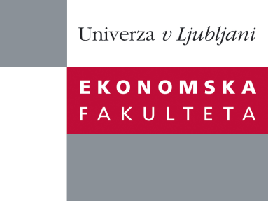

Raziskovalni center Ekonomske fakultete
organizira znanstveno - raziskovalni seminar,
ki bo v sredo, 23. Aprila 2014, ob 12:00 uri
v P-109 na Ekonomski fakulteti v Ljubljani.

Predstavljen bo članek:

"Utilizing betting markets for rating sports teams within and across competitions"

avtor: dr. Erik Štrumbelj, Fakulteta za računalništvo in informatiko, Univerza v Ljubljani

“Our research was motivated by a basketball scout who posed the problem of ranking European national leagues on average team quality. Addressing this problem is relevant not only to setting scouting priorities, but also to determining quotas/seedings for international club competitions. Typically, we would fit a latent strength rating model, such as the classical Elo rating, using observed outcomes. However, in most practical cases, this is insuficient for an accurate estimate of a team's strength, especially in the early parts of the competition season. We hypothesized that this can be dealt with by taking advantage of betting odds, which require little preprocessing and have been shown to be the most accurate source of probability forecasts for sports. This can be viewed as a passive form of crowdsourcing - we utilize the efforts of the bookmakers and the public, both motivated by monetary rewards to incorporate all relevant information. We base our approach on the Elo rating. Instead of the usual incremental updating, we implement batch fitting, which facilitates propagation of information backwards in time. Batch fitting our statistical model requires optimization over a large set of parameters, but deriving the gradient analytically reduces the run times to a few seconds. Preliminary evaluation on European club competitions and NBA basketball confirmed that the proposed approach is substantially better both in terms of higher predictive accuracy and fewer games needed to converge.”

Na brezplačni seminar se lahko prijavite v Službi za znanstveno raziskovalno delo, po telefonu (01) 58-92-490, ali po e-pošti research.seminars@ef.uni-lj.si, in sicer do torka, 22.4.2014
Vljudno vabljeni!

