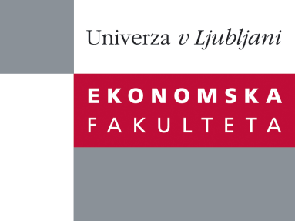

Raziskovalni center Ekonomske fakultete
organizira znanstveno - raziskovalni seminar,
ki bo v sredo, 21. Novembra 2012, ob 12:00 uri
v P-109 na Ekonomski fakulteti v Ljubljani.

Predstavljen bo članek:

“Firm-Level Labour Demand: Adjustment in Good Times and During the Crisis”

avtor: prof. dr. Lubomír Lízal, (Center for Economic Research & Graduate Education - Economics Institute)

˝Using a large panel of Czech manufacturing firms with 50 or more employees, we update the firm-level labour demand elasticity estimates for 2002–2009. The economic crisis of 2008–2009 provides a source of variation needed for getting estimates that cover not only times of growth, but also a period of economic contraction. We find that in normal times (until 2007), the short-term elasticity is -0.53 with respect to wages and 0.43 with respect to sales, while the long-term elasticities are close to or below unity, standing at -0.94 for wages and 0.76 for sales. Both the wage and sales elasticities increased during the crisis, suggesting that firms became demand constrained, but only the sales elasticity is significantly different. The long-term wage elasticity close to -1 in the period before and during the crisis suggests that firms’ employment decisions are made within fixed budgets. Finally, we find that the inclusion of workers hired through temporary work agencies does not significantly affect the results, indicating that firms take into account total labour when deciding on employment and that hired workers are used as an equal labour demand channel with lower adjustment costs. As a robustness check, our results are qualitatively comparable with the narrative evidence from an ad-hoc firm-level survey on wage and price formation conducted in 2007 and 2009 within the ESCB Wage Dynamics Network.˝

Na brezplačni seminar se lahko prijavite v Službi za znanstveno raziskovalno delo, po telefonu (01) 58-92-490 ali po e-pošti research.seminars@ef.uni-lj.si, do torka, 22.11.2012.

Vljudno vabljeni!

