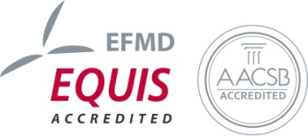
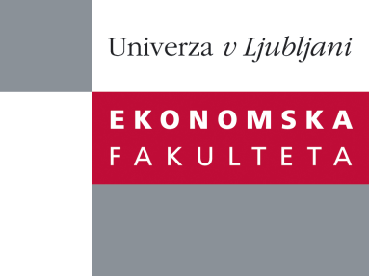

Raziskovalni center Ekonomske fakultete
organizira znanstveno - raziskovalni seminar,
ki bo v četrtek, 24. aprila 2014, ob 12:00 uri
v P-109 na Ekonomski fakulteti v Ljubljani.

Predstavljena bo raziskava:

“Determinants of Audit Fees in Slovenia”

avtorji: mag. Aleksander Igličar, dr. Maja Zaman Groff in dr. Domen Trobec, Ekonomska fakulteta, Univerza v Ljubljani

“An extensive body of research has been examining the determinants of audit fees over the past 35 years. Much research has followed the seminal work by Simunic (1980) who identified (a) size of the client, (b) complexity of the client and (c) risk of the client to be the main determinants of audit fees. Numerous researchers have upgraded his original work by identifying additional determinants of audit fees; in spite of some inconsistencies in the reported findings, there is a general consent among researchers that the determinants, affecting audit fees, are client-specific and auditor-specific. The aim of our study is to identify the characteristics of audit fees in Slovenia. As compared to the settings that have been thoroughly studied in the existing literature, Slovenia has a relatively short auditing tradition. Moreover, the developments in its audit market have led to comparatively low audit fees. Identifying the determinants of audit fees in such setting is important to understand. Higher complexities and risks should reflect in higher audit fees or else audit quality is at risk. In our research we studied audit fees of Slovenian companies from Manufacturing Industry (Industry C from Slovenian Standard Classification of Activities - SKD) in years from 2009 to 2012. We matched audit fees with income statement and balance sheet data, auditor-related data and additional information from annual reports to identify the determinants of audit fees in this period. To the best of our knowledge this is the first comprehensive research of Audit Fees in Slovenia. Our initial regression results show quite significant results which could be interesting to researchers, audit companies, their clients as well as policymakers.”

Na brezplačni seminar se lahko prijavite v Službi za znanstveno raziskovalno delo, po telefonu (01) 58-92-490, ali po e-pošti research.seminars@ef.uni-lj.si, in sicer do srede, 23. aprila 2014.
Vljudno vabljeni!

