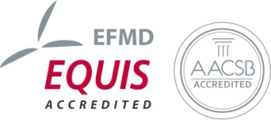
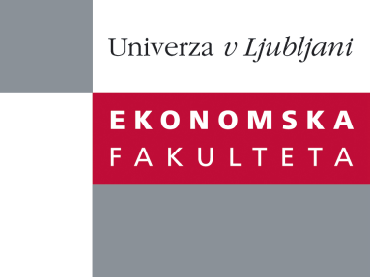

Raziskovalni center Ekonomske fakultete
organizira znanstveno - raziskovalni seminar,
ki bo v sredo, 05. December 2012, ob 12:00 uri
v P-109 na Ekonomski fakulteti v Ljubljani.

Predstavljen bo članek:

“The cognitive limits of matching mechanisms"
avtor: Pablo Guillen Alvarez (Faculty of Arts and Social Sciences, School of EconomicsThe University of Sydney)

˝We test the effect of advice on the well know top trading cycles (TTC) matching algorithm. We compare three treatments involving third party advise [right advise (R), wrong advise (W), and both right and wrong advise (RW)] to a no advise baseline (B). In line with previous literature the truth telling rate is higher than 80% in B, but it becomes as low as 20% in W. Truth telling rates are also significantly lower in R than in B, and much lower in RW than in B. Truth telling seems to work as a default strategy, which can be easily influenced by advise. The implementation of incentive compatible matching mechanisms in real life market design may have been misguided by laboratory experimentation.˝

Na brezplačni seminar se lahko prijavite v Službi za znanstveno raziskovalno delo, po telefonu (01) 58-92-490 ali po e-pošti research.seminars@ef.uni-lj.si, do srede, 05.12.2012.

Vljudno vabljeni!

