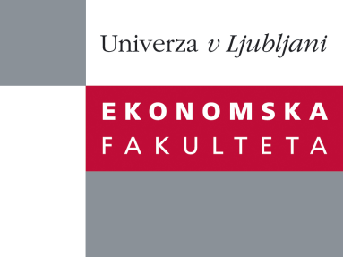

Raziskovalni center Ekonomske fakultete
organizira znanstveno - raziskovalni seminar,
ki bo v torek, 25. Marca 2014, ob 11:00 uri
v P-108 na Ekonomski fakulteti v Ljubljani.

Predstavljen bo članek:

"Challenges for Processing Events in Logistics Processes"

Avtor: Prof. Dr. Jan Mendling, WU Vienna, Avstrija

»Business Process Management has proven to be a useful approach to increase the performance of enterprises, with most of its success stories being associated with office work and service processes. In this talk, I revisit the essential ideas of business process management and will discuss the challenges of GET Service, a research project in the EU's 7th Framework Programme. The main aim of that project is to develop the European Wide Service Platform for Green European Transportation (GET Service). In this context, I will discuss conceptual challenges of combining BPM concepts and complex event processing with needs of logistics monitoring. «

Bio: Prof. Dr. Jan Mendling is a Full Professor and head of the Institute for Information Business at WU Vienna. His research areas include Business Process Management, Conceptual Modelling and Enterprise Systems. He studied Business Computer Science at University of Trier (Germany) and UFSIA Antwerpen (Belgium), and received a PhD degree from WU Vienna. After being a postdoc with QUT Brisbane (Australia) and a junior professor at HU Berlin, he moved back to WU in 2011. He has published more than 200 research papers and articles, among others in ACM Transactions on Software Engineering and Methodology, IEEE Transaction on Software Engineering, Information Systems, Data & Knowledge Engineering, and Decision Support Systems. He is member of the editorial board of three international journals, one of the founders of the Berlin BPM Community of Practice, organizer of several academic events on process management, member of the IEEE Task Force on Process Mining, and board member of the Austrian Gesellschaft für Prozessmanagement. His Ph.D. thesis has won the Heinz-Zemanek-Award of the Austrian Computer Society and the German Targion-Award for dissertations in the area of strategic information management.

Na brezplačni seminar se lahko prijavite v Službi za znanstveno raziskovalno delo, po telefonu (01) 58-92-490, ali po e-pošti research.seminars@ef.uni-lj.si, in sicer do ponedeljka, 24.3.2014.
Vljudno vabljeni!

