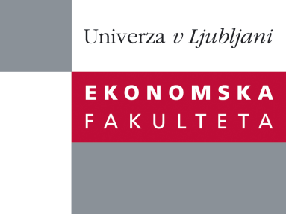

Raziskovalni center Ekonomske fakultete
organizira znanstveno - raziskovalni seminar,
ki bo v četrtek, 22. Novembra 2012, ob 12:00 uri
v P-109 na Ekonomski fakulteti v Ljubljani.

Predstavljen bo članek:

“Social Media as Enabler of Crowdsourcing Business Model”

avtor: Ivan Župič

Sourcing ideas and inputs from the crowd is being increasingly used by companies in online settings.This chapter is based on a case study of microstock business model – a crowdsourcing-based model which irreversably transformed stock photography industry. Social media building blocks, such as social networking features, discussion boards and blogs are used for community building and promoting communication among crowdsourcing participants. Companies embarking on crowdsourcing initiatives can enhance participants' motivations through social media and enable online learning with improved communication and information diffusion.

Na brezplačni seminar se lahko prijavite v Službi za znanstveno raziskovalno delo, po telefonu (01) 58-92-490 ali po e-pošti research.seminars@ef.uni-lj.si, do srede, 21.11.2012.

Vljudno vabljeni!

