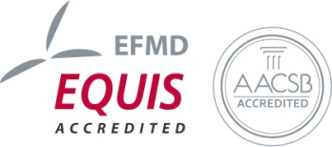
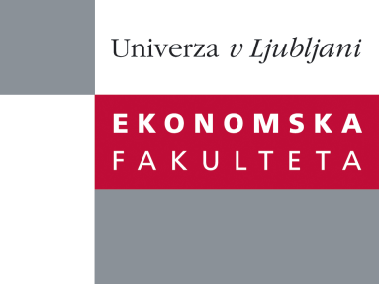

Raziskovalni center Ekonomske fakultete
organizira znanstveno - raziskovalni seminar,
ki bo v četrtek, 13. Decembra 2012, ob 12:00 uri
v P-109 na Ekonomski fakulteti v Ljubljani

Predstavljen bo članek:

“Can oversight mitigate auditor’s motivated reasoning? An experimental study"
avtorji: prof. dr. Sergeja Slapničar, doc. dr. Maja Zaman Groff, doc. dr. Igor Lončarski, Univerza v Ljubljani, Ekonomska fakulteta
Increasing evidence of auditors’ failure to provide an independent opinion on true and fair view of financial position of firms during the financial crisis has reopened the debates about effective measures to ensure auditor’s independence. The purpose of this paper is to examine the effectiveness of oversight on two prominent determinants of auditor’s biased opinion – financial incentives and personal relationship with a client. We conjecture that oversight, intended to mitigate biases, is more effective for biases arising from financial incentives than biases arising from personal relationship. The latter are to some extent unconscious and therefore insensitive to oversight. To analyze the hypotheses we conduct a two-by-two-by-two between subject experiment with 234 students involving a choice task. We find that oversight has a significant effect on auditor’s choice arising from financial incentives. While personal relationship was not found to significantly affect choices, we find that it significantly decreases the effectiveness of oversight. Our results show that while oversight may effectively mitigate conscious bias it does not affect the unconscious one, arising from personal relationship beyond financial incentive. The findings contribute to the recent regulatory discussions on measures to increase auditors’ independence. They show that in addition to oversight alternative solutions are needed to mitigate the bias arising from personal relationship. Audit firm rotation may prevent diluting effects of oversight by terminating the long-term auditor-client relationships and financial dependency.

Na brezplačni seminar se lahko prijavite v Službi za znanstveno raziskovalno delo, po telefonu (01) 58-92-490 ali po e-pošti research.seminars@ef.uni-lj.si, do srede, 12.12.2012.
Vljudno vabljeni!

