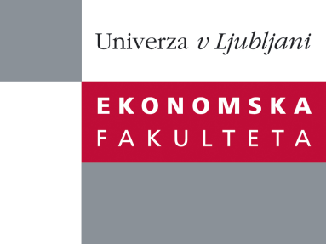

Raziskovalni center Ekonomske fakultete
organizira znanstveno - raziskovalni seminar,
ki bo v sredo, 21. Novembra 2012, ob 13:45 uri
v P-213 na Ekonomski fakulteti v Ljubljani.

Predstavljen bo članek:

˝Does B2B Service Brand Identity influence performance?˝

avtor: prof. dr. Leslie de Chernatony, (Universita della Svizzera italiana, Lugano, Switzerland and Aston Business School, Birmingham, UK)

In the literature there are claims that firms which have a distinct and cohesive brand identity achieve higher brand performance. However, such claims are often based on theoretical models and there is little empirical research to test such a proposition. This seminar will explore how an empirical study amongst 421 senior marketing executives was used to test this proposition.

Na brezplačni seminar se lahko prijavite v Službi za znanstveno raziskovalno delo, po telefonu (01) 58-92-490, ali po e-pošti research.seminars@ef.uni-lj.si, in sicer do torka, 20.11.2012.

Vljudno vabljeni!

