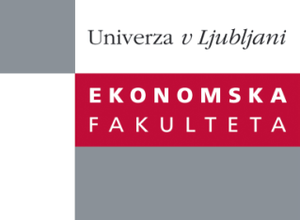

Raziskovalni center Ekonomske fakultete
organizira znanstveno - raziskovalni seminar,
ki bo v četrtek , 20. Decembra 2012, ob 12:00 uri
v P-109 na Ekonomski fakulteti v Ljubljani.

Predstavljen bo članek:

“Marketized philanthropy: Kiva’sutopian ideology of entrepreneurial philanthropy"

Avtor: doc. dr. Domen Bajde, Ekonomska fakulteta, Univerza v Ljubljani

As the impact of market actors and their doctrines on philanthropy gradually increases, the debate between the proponents and the critics of ‘marketization’ of philanthropy intensifies. Curiously, the debate has largely centred on ‘philanthrocapitalists’ and philanthropic professionals, while less attention has been devoted to the ways in which the newly emergent philanthropic ideologies and practices are ‘marketed’ to and adopted by the broader audience of philanthropic givers. In response, we explore the ideological elements that make lending through Kiva, an emergent micro-finance charity, meaningful to its creators and supporters. A combination of interpretive methods is used to outline Kiva’s ideology of entrepreneurial philanthropy. This utopian ideology is found to legitimize ‘marketized’ philanthropic practices by invoking alternative conceptions of poverty, social progress and philanthropy (i.e., representations of philanthropic giving, philanthropic benefactors and beneficiaries and the relations between them).

Na brezplačni seminar se lahko prijavite v Službi za znanstveno raziskovalno delo, po telefonu (01) 58-92-490 ali po e-pošti research.seminars@ef.uni-lj.si, do srede, 19.12.2012.
Vljudno vabljeni!

