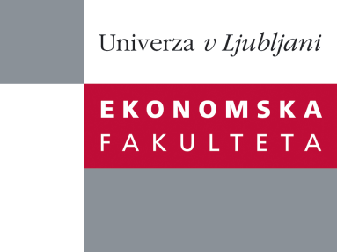

Raziskovalni center Ekonomske fakultete
organizira znanstveno - raziskovalni seminar,
ki bo v sredo,16. novembra 2011, ob 12:00 uri
v P-109 na Ekonomski fakulteti v Ljubljani.

Doc. dr. Adriana Rejc Buhovac in
doc. dr. Maja Zaman Groff

(Univerza v Ljubljani, Ekonomska fakulteta)

bo predstavili članek:

“Contemporary performance measurement systems in Central and Eastern Europe: A synthesis of the empirical literature”

The paper presents a synthesis of contemporary performance measurement systems (PMS) research in Central and Eastern Europe (CEE). The literature review is organized around four determinants of contemporary PMS: multidimensionality, strategic focus, cascading, and alignment between PMS and compensation. Discussion of findings and future research directions are suggested along these four determinants while taking into account different institutional, legislative, and cultural contexts of the CEE countries. The paper delivers tentative implications for management researchers and management accounting researchers to guide future thinking and research on PMS in CEE countries. Finally, relevance of research findings for managers is discussed.
Na brezplačni seminar se lahko prijavite v pisarni RCEF, po telefonu (01) 58-92-490, ali po e-pošti na naslov sodelavec.rcef@ef.uni-lj.si do torka, 15.11.2011.
Vljudno vabljeni!

