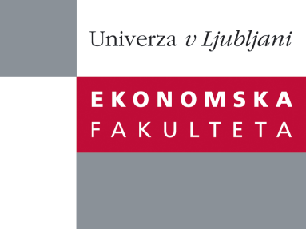

Raziskovalni center Ekonomske fakultete
organizira znanstveno - raziskovalni seminar,
ki bo v sreda, 19. oktobra 2011, ob 12:00 uri
v P-109 na Ekonomski fakulteti v Ljubljani.

Dr. Egon Zakrajšek

(Federal Reserve Board, ZDA)

bo predstavil članek:

“Uncertainty, Financial Frictions, and Investment Dynamics”

"This paper analyzes—both empirically and theoretically—how fluctuations in uncertainty interact with financial market imperfections in determining economic outcomes. In a standard bond-contracting framework, an increase in uncertainty benefits equity holders at the expense of bondholders, and to the extent that firms face significant frictions in financial markets, increased uncertainty implies a higher cost of capital and hence a decline in investment. The reduction in credit supply also hampers the efficient reallocation of capital and causes an endogenous decline in total factor productivity (TFP) that amplifies the economic downturn. Using both aggregate time-series and firm-level data, we find strong evidence supporting the notion that financial frictions play a major role in shaping the uncertainty-investment nexus. We then develop a tractable general equilibrium model in which individual firms face time-varying uncertainty and imperfect capital markets when issuing risky bonds and equity to finance investment projects. We calibrate the uncertainty process using micro-level estimates of shocks to the firms’ profits and show that the combination of uncertainty shocks and financial frictions can generate fluctuations in economic activity that are observationally equivalent to the TFP-driven business cycles."
Na brezplačni seminar se lahko prijavite v pisarni RCEF, po telefonu (01) 58-92-490, ali po e-pošti na naslov sodelavec.rcef@ef.uni-lj.si do torka, 18.10.2011.
Vljudno vabljeni!

