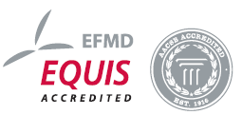
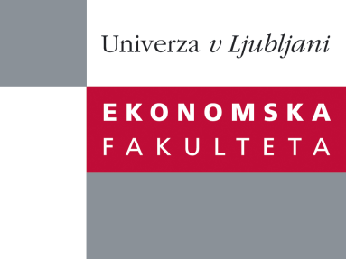

Raziskovalni center Ekonomske fakultete
organizira znanstveno-raziskovalni seminar,
ki bo v ponedeljek, 04. aprila 2011 ob 16:30 uri
v predavalnici P-201 na Ekonomski fakulteti v Ljubljani.

Prof. dr. Anders Dysvik
( BI Norwegian Business School)
bo predstavil raziskovalno temo:
˝User-friendly human resource management”

While macro Human Resource Management research suggest a positive relationship between "high performance work practices" and organizational performance, the mechanisms relating such practices with performance at different levels of analysis remains unclear. Prof. dr. Dysvik will present recent studies investigating whether line manager support may represent a contingency influencing the relationship between selected HR practices, work design features, and employee outcomes at the individual and business unit levels of analysis. Finally, implications and directions for future research on the role of line managers as implementers of HRM will be discussed.

O predavatelju: Anders Dysvik, PhD is an Associate Professor of Organizational Psychology at the Department of Leadership and Organizational Management, Norwegian School of Management. His work has been accepted for publication in journals such as Journal of Vocational Behavior, International Journal of Human Resource Management, Human Resource Management Journal, Personnel Review, and European Journal of Work and Organizational Psychology. He is at the review board of Educational Psychology and a reviewer for journals such as Human Resource Management and European Journal of Work and Organizational Psychology. He teaches executive, master of science and bachelor programs. He is involved in research collaboration projects with Norwegian organizations and is often hired to hold invited talks for practitioners on HRM issues.

Na brezplačni seminar se lahko prijavite v pisarni RCEF po telefonu (01) 58-92-490, ali po e-pošti na naslov sodelavec.rcef@ef.uni-lj.si do petka, 01. aprila 2011.
Vljudno vabljeni!

