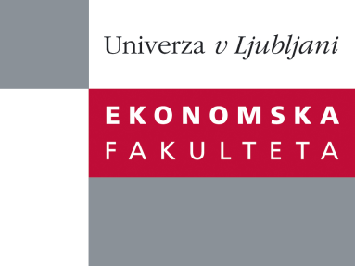

Raziskovalni center Ekonomske fakultete
organizira znanstveno - raziskovalni seminar,
ki bo v četrtek, 3. Aprila 2014, ob 12:00 uri
v P-109 na Ekonomski fakulteti v Ljubljani.

Predstavljen bo članek:

“Export Venture Strategic Goals, Competitive Advantages, and Performance Outcomes:
The Relevance of Architectural Capabilities and Degree of Internationalization”

avtor: Constantine S. Katsikeas, Ph.D., Leeds University, Velika Britanija

“The difference between intended and realized strategy has been well established in the theoretical literature in strategic management for many years. The international business literature suggests that the difficulty of realizing intended strategic goals are even greater when managers are dealing with markets that are more distant and differ from the home market. Such implementation failures can be costly in terms of both resources wasted and benefits foregone. Yet, we still have little understanding of why it is so hard for many firms to achieve their strategic objectives or the performance consequences of failing to do so. We study this issue in the context of firms’ export ventures. Based on a random sample of exporting firms, our results make four contributions. First, we offer evidence supporting the existence of previously conceptualized gaps between exporters’ intended strategic goals and the positional advantages that they subsequently manage to realize. Second, we provide a calibration of the performance consequences of such difficulties and show that, from a financial performance perspective, these can be significant. Third, we identify weaknesses in firms’ architectural export venture capabilities as an important cause of their inability to realize intended strategic goals in export markets. We show that exporters stronger in such capabilities are better able to realize their intended strategic objectives in export markets. Fourth, we show that the beneficial effect of a firm’s architectural export venture capabilities is moderated by its internationalization level.”

Na brezplačni seminar se lahko prijavite v Službi za znanstveno raziskovalno delo, po telefonu (01) 58-92-490, ali po e-pošti research.seminars@ef.uni-lj.si, in sicer do srede, 2.4.2014.
Vljudno vabljeni!

