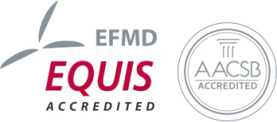
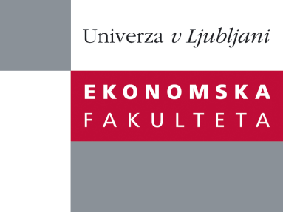

Raziskovalni center Ekonomske fakultete
organizira znanstveno - raziskovalni seminar,
ki bo v sredo, 3. Julija 2013, ob 12.00 uri
v P-109 na Ekonomski fakulteti v Ljubljani.

Predstavljen bo članek:

˝The effects of Government Spending in a Small Open Economy within a Monetary Union˝

avtor: Matija Lozej, Banka Slovenije (soavtorji: Daragh Clancy, Central Bank of Ireland in Pascal Jacquinot, European Central Bank)

We use the EAGLE model to show the heterogeneity of responses of small open economies within a monetary union to common shocks. The paper extends the public spending in the model to allow for: a distinction between public consumption and investment; an import-content of public expenditure; the accumulation of public capital; and complementarities between public and private consumption. The key findings are that, first, productive public capital has strong and long-lasting effects on a small open economy and that it improves the external competitiveness of the country. Second, public spending on foreign goods reduces the size of fiscal multipliers in the short run, but in case of public investment has little effect in the medium run. Third, an ex-ante budget neutral restructuring of public expenditure towards public investment has beneficial effects in the medium run, while the short-run effects depend on the degree of complementarity between private and public consumption.

Na brezplačni seminar se lahko prijavite v Službi za znanstveno raziskovalno delo, po telefonu (01) 58-92-490, ali po e-pošti research.seminars@ef.uni-lj.si, in sicer do torka, 2.7.2013
Vljudno vabljeni!

