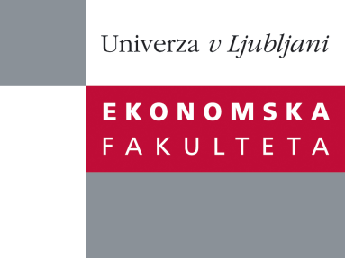

Raziskovalni center Ekonomske fakultete
organizira znanstveno - raziskovalni seminar,
ki bo v sredo, 26. Marca 2014, ob 12:00 uri
v P-109 na Ekonomski fakulteti v Ljubljani.

Predstavljen bo članek:

“Internationalizing strategies: Export diversity or focus?”

avtor: dr. Andreja Jaklič in doc. dr. Anže Burger Fakulteta za družbene vede, Slovenija (soavtorji: prof. dr. Desislava Dikova, WU Vienna, dr. Aljaž Kunčič Fakulteta za družbene vede)

“The question how much internationalization is beneficial for emerging-market small and medium enterprises (EM SMEs) remains challenging to answer for both international business scholars and managers. First time internationalizing EM SMEs tend to have high failure rates, in spite of rising policy efforts of home governments to support them. We explore export strategies of first time exporters and focus on the scope of SMEs internationalization activities. We tackle the question whether more focused or more diversified internationalization through exporting is beneficial for EM SMEs. We examine the impact of foreign market (geographical) diversification, product diversification and export intensity (with respect to markets and products exported) on firm performance on an entire population of first-time exporters from an emerging east European market using a panel population data in the period 1991-2010. In addition, we test whether a complex export strategy—an export strategy of simultaneous product and market export diversification—is beneficial for EM SMEs. We find that rapid and diversified internationalization significantly improves productivity for EM SMEs. Furthermore, EM SMEs with complex export strategies enjoy significantly improved sales performance.”

Na brezplačni seminar se lahko prijavite v Službi za znanstveno raziskovalno delo, po telefonu (01) 58-92-490, ali po e-pošti research.seminars@ef.uni-lj.si, in sicer do torka, 25.3.2014.
Vljudno vabljeni!

