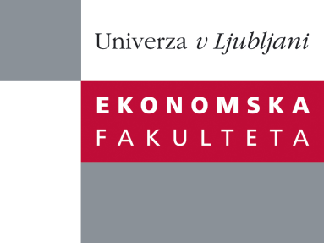

Raziskovalni center Ekonomske fakultete
organizira znanstveno - raziskovalni seminar,
ki bo v četrtek, 27. oktobra 2011, ob 12:00 uri
v P-109 na Ekonomski fakulteti v Ljubljani.

Doc.dr. Ljubica Knežević Cvelbar

(Univerza v Ljubljani, Ekonomska fakulteta)

bo predstavil članek:

˝An importance-performance analysis of economics, environmental and social performance of tourism firms˝

The most comprehensive approach to achieve sustainable operations at the firm level is the Triple Bottom Line (TBL) approach. However, tourism industry seems to be little aware of the existence of TBL or its relevance to the achievement of sustainable development. In this paper we address some of the challenges tourism firms are facing as part of the process of implementing TBL in practice. These challenges include how to measure performance in tourism firms in sustainable way and provide a valid set of indicators in each of three sustainability pillars. We also identify the areas where tourism firms must concentrate in order to sustain their business operations in the future.

Na brezplačni seminar se lahko prijavite v Službi za znanstveno raziskovalno delo, po telefonu (01) 58-92-490, ali po e-pošti na naslov research.seminars@ef.uni-lj.si do srede, 26.10.2011.
Vljudno vabljeni!

