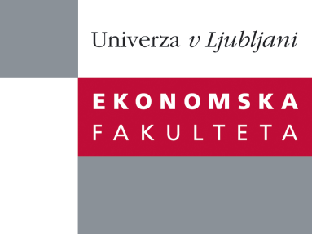

Raziskovalni center Ekonomske fakultete
organizira znanstveno - raziskovalni seminar,
ki bo v sredo, 26. oktobra 2011, ob 12:00 uri
v P-109 na Ekonomski fakulteti v Ljubljani.

mag. Matevž Raškovič

(Univerza v Ljubljani, Ekonomska fakulteta)

bo predstavil članek:

“Application of weighted blockmodeling in the analysis of small EU states` export patterns”

"This research note builds on the recent renaissance of network-based methodologies from the social sciences within economics. It outlines the applicability of (social) network analysis, and in particular builds on the recent methodological developments related to generalized blockmodeling of weighted networks. The research illustratively analyzes the inter-country EU export flows for 2008, and in particular focuses on the issue of universality vs. contingency of export patterns of small EU states. It provides a short interdisciplinary overview of the employed methodology, key theoretical concepts, and highlights possible extensions and avenues for further application. The presented results refute the universality perspective of small states’ export patterns, at least in an inter-country EU context. The research note will hopefully stimulate the increasing use of network analysis and generalized blockmodeling in the analysis of international trade, as well as the fields of international economics and business.˝
"
Na brezplačni seminar se lahko prijavite v Službi za znanstveno raziskovalno delo, po telefonu (01) 58-92-490, ali po e-pošti na naslov research.seminars@ef.uni-lj.si do torka, 25.10.2011.
Vljudno vabljeni!

