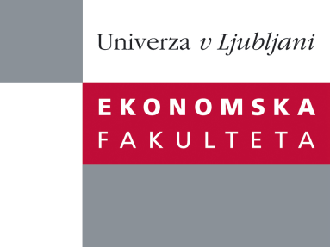

Raziskovalni center Ekonomske fakultete
organizira znanstveno - raziskovalni seminar,
ki bo v četrtek, 4. Julija 2013, ob 12:00 uri
v P-109 na Ekonomski fakulteti v Ljubljani.

Predstavljen bo članek:

“Knowledge Hiding in Organizations: Special Case of Independent Contractors”
avtorica: prof. dr. Catherine Connelly, DeGroote School of Business
McMaster University, Kanada
Most organizations expect employees to share their best ideas with their co-workers; this can reduce costs and improve productivity. However, many employees are reluctant to do so. Instead, they engage in “knowledge hiding”, where they refuse requests for information from colleagues. This presentation introduces the concept of knowledge hiding, and discusses its applicability to the special case of independent contractors (non-standard workers who are technically not employees but who perform work at the client site). Preliminary results from a longitudinal study will be discussed.

Bio: Catherine Connelly is a Canada Research Chair in Organizational Behaviour at the DeGroote School of Business at McMaster University in Hamilton, Canada. Her research interests include knowledge hiding, the impact of communication technologies on worker attitudes, and non-standard employment arrangements. Her research has appeared in the Journal of Management, the Journal of Applied Psychology, Journal of Organizational Behaviour, the Journal of Management Information Systems, and several other outlets. She is an associate editor for Human Relations and the Canadian Journal of Administrative Sciences.

Na brezplačni seminar se lahko prijavite v Službi za znanstveno raziskovalno delo, po telefonu (01) 58-92-490, ali po e-pošti research.seminars@ef.uni-lj.si, in sicer do srede, 03.07.2013.

Vljudno vabljeni!

