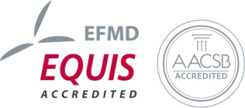
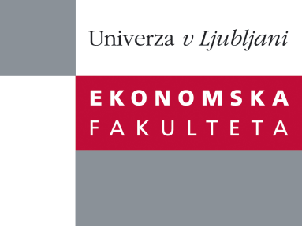

Raziskovalni center Ekonomske fakultete
organizira znanstveno - raziskovalni seminar,
ki bo v četrtek, 03. novembra 2011, ob 12:00 uri
v P-109 na Ekonomski fakulteti v Ljubljani.

izr. prof. dr. Aleš Groznik

(Univerza v Ljubljani, Ekonomska fakulteta)

bo predstavili članek:

˝Multi utility management- Myth or reality? Transformations within the European Union˝
In the last decade energy utility sector has undergone major changes in terms of liberalisation, increased competition, efforts in improving energy efficiency, and in new technological solution such as smart meter and grid operations. The purpose of this paper is to show potentials and challenges in utility sector due to introduction of information technology. There are new information technology solutions on the horizon that will not only introduce new technical and organisational concepts, but have a very strong potential to radically change modus operandi of utility companies. Utility companies will have to switch from energy procurement, distribution and sales into IT-driven efficient management of complex information. Utility companies will have to redefine their supply chains in terms of multi-commodities; delivering several products or services to the customer, multi-jurisdictions; supply chains spreading across several jurisdictions and multi-tariffs; as a result of dynamic pricing and multi-commodities. Utility companies are facing extensive and comprehensive changes that have potential to significantly restructure the way utility companies are operating today. Therefore it is of vital importance that we articulate challenges in multi utility management that utility companies will have to overcome in order to significantly benefit from AMI introduction. The paper will take a special case of the transformations that are happening in the EU and how AMI will change energy realities of the EU.
Na brezplačni seminar se lahko prijavite v Službi za znanstveno raziskovalno delo, po telefonu (01) 58-92-490, ali po e-pošti na naslov research.seminars@ef.uni-lj.si do srede, 02.11.2011.
Vljudno vabljeni!

