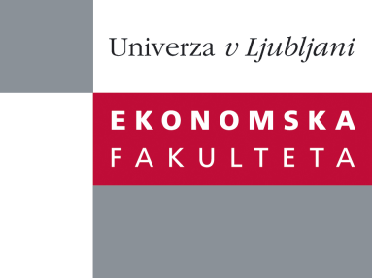

Raziskovalni center Ekonomske fakultete
organizira znanstveno - raziskovalni seminar,
ki bo v sredo, 09. Novembra 2011, ob 12:00 uri
v P-109 na Ekonomski fakulteti v Ljubljani.

Dr. Milford Bateman

(Faculty of Economics and Tourism, University of Juraj Dobrila Pula in freelance consultant on Local Economic Development)

bo predstavil članek:

“A Sub-Prime Lending Disaster Comes to the Western Balkans: The Strange Case of Microfinance”

˝ In this paper we challenge the uplifting narrative governing microfinance outcomes in post-war Bosnia and Herzegovina (hereafter Bosnia), and by extension in other developing and transition countries. For more than thirty years, the concept of microfinance has been lauded for its supposedly amazing power to use self-help and tiny ‘business’ projects to eradicate poverty and promote ‘bottom-up’ economic and social development (De Soto, 1989; Yunus, 1989; Robinson, 2001). The initial post-war promise in Bosnia was for poverty alleviation to be quickly secured through large numbers of sustainable jobs in microenterprises, additional income generated in the community, empowered women, an accelerated accumulation of social capital and, eventually, growing numbers of conversions of informal microenterprises into more productive formal SMEs (World Bank, 1997). However, in none of these important areas do we find that the microfinance model has generated the outcomes claimed for it: on the contrary, we document a number of seriously deleterious trajectories associated with the microfinance model that have combined, in our view, to help propel the Bosnian economy into its current deep economic crisis. In sum, we argue that the microfinance model as it has emerged in Bosnia is essentially a modified sub-prime-style lending program that, like the original sub-prime lending disaster in the USA, prioritised the private enrichment goals of senior managers quite irrespective of the enormous damage being done to the fabric of the Bosnian economy and society˝.

Na brezplačni seminar se lahko prijavite v Službi za znanstveno raziskovalno delo, po telefonu (01) 58-92-490, ali po e-pošti na naslov research.seminars@ef.uni-lj.si do torka, 08.11.2011.
Vljudno vabljeni!

