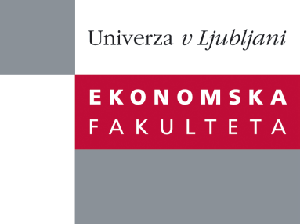

Raziskovalni center Ekonomske fakultete
organizira znanstveno - raziskovalni seminar,
ki bo v petek, 08. aprila 2011, ob 13. uri
v sejni sobi CISEF-a na Ekonomski fakulteti v Ljubljani.

Prof. dr. Tony Fang
(School of Business, Stockholm University)

bo predstavil članek:
˝Yin Yang – A new perspective on culture”

In this article I propose a Yin Yang perspective to understand culture. Based on the indigenous Chinese philosophy of Yin Yang, I conceptualize culture as possessing inherently paradoxical value orientations, thereby enabling it to embrace opposite traits of any given cultural dimension. I posit that potential paradoxical values coexist in any culture; they give rise to, exist within, reinforce, and complement each other to shape the holistic and dynamic nature of culture. Seen from the Yin Yang perspective, all cultures share the same potential in value orientations, but at the same time they are also different from each other because each culture is a unique dynamic portfolio of self-selected globally available value orientations as a consequence of that culture’s all-dimensional learning over time.

O predavatelju: Tony Fang is Full Professor of Business Administration at School of Business Stockholm University (SU). He is also Visiting Professor at Europe China Institute, Nyenrode Business University, the Netherlands and Visiting Professor at Asia Research Centre, Copenhagen Business School (CBS). Tony Fang holds his PhD in International Management/Industrial Marketing from Linköping Institute of Technology (LiTH), Sweden. He has also been Visiting Scholar in the Political Science Department, Massachusetts Institute of Technology (MIT, host professor Lucian W. Pye) and he is probably best known internationally for his research on Chinese business negotiating style and his debates on Geert Hofstede's culture theory. His research and teaching interests include global cross cultural management, industrial marketing and purchasing/sourcing, international business negotiation, and China business studies. Tony Fang serves on the editorial board of the International Journal of Cross Cultural Management (IJCCM), the International Business Review (IBR) and Journal of Intercultural Communication (JIC). He is also Book Review Editor for IBR - the official journal of the European International Business Academy (EIBA). Tony Fang is the co-editor of the special issue on "The Changing Chinese Culture and Business Behaviour published by IBR(Volume 17, Issue 2, 2008) and co-editor of the special issue section on "Cross Cultural Management in the Age of Globalization" by IJCCM (Volume 9, Issue 2, 2009).

Na brezplačni seminar se lahko prijavite v pisarni RCEF po telefonu (01) 58-92-490, ali po e-pošti na naslov sodelavec.rcef@ef.uni-lj.si do četrtka, 07.04.2011.
Vljudno vabljeni!

