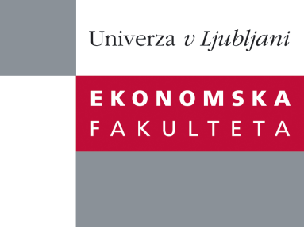

Raziskovalni center Ekonomske fakultete
organizira znanstveno - raziskovalni seminar,
ki bo v sredo, 02. Novembra 2011, ob 12:00 uri
v P-109 na Ekonomski fakulteti v Ljubljani.

Prof.dr. Igor Masten

((Univerza v Ljubljani, Ekonomska fakulteta)

bo predstavil članek:

“Forecasting with Factor-augmented Error Correction Models”

"As a generalization of the factor-augmented VAR (FAVAR) and of the Error
Correction Model (ECM), Banerjee and Marcellino (2009) introduced the Factoraugmented Error Correction Model (FECM). The FECM combines error-correction, cointegration and dynamic factor models, and has several conceptual advantages over standard ECM and FAVAR models. In particular, it uses a larger dataset compared to the ECM and incorporates the long-run information lacking from the FAVAR because of the latter's specication in dierences. In this paper we examine the forecasting performance of the FECM by means of an analytical example, Monte Carlo simulations and several empirical applications. We show that relative to the FAVAR, FECM generally oers a higher forecasting precision and in general marks a very useful step forward for forecasting with large datasets˝.

Na brezplačni seminar se lahko prijavite v Službi za znanstveno raziskovalno delo, po telefonu (01) 58-92-490, ali po e-pošti na naslov research.seminars@ef.uni-lj.si do torka, 01.11.2011.
Vljudno vabljeni!

