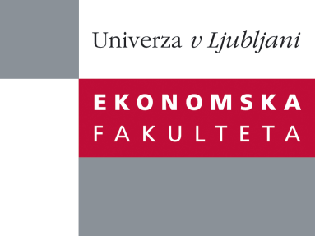

Raziskovalni center Ekonomske fakultete
organizira znanstveno - raziskovalni seminar,
ki bo v četrtek, 24. novembra 2011, ob 12:00 uri
v P-109 na Ekonomski fakulteti v Ljubljani.

izr. prof. dr. Mateja Drnovšek

(Univerza v Ljubljani, Ekonomska fakulteta)

bo predstavila članek:

˝The Nature and Experience of Entrepreneurial Passion˝

Entrepreneurial passion plays an important role in entrepreneurship, but theoretical understanding of what it is and what it does is lacking. We build on fragmented and disparate extant work to conceptualize the nature of entrepreneurial passion associated with salient entrepreneurial role identities. We also theorize the mechanisms of the experience of entrepreneurial passion that provide coherence to goal-directed cognitions and behaviours during the pursuit of entrepreneurial effectiveness.

Na brezplačni seminar se lahko prijavite v Službi za znanstveno raziskovalno delo, po telefonu (01) 58-92-490, ali po e-pošti na naslov research.seminars@ef.uni-lj.si, in sicer do srede, 23.11.2011.
Vljudno vabljeni!

