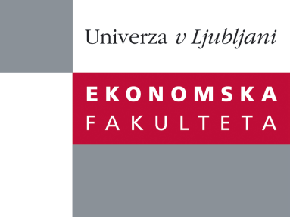

Raziskovalni center Ekonomske fakultete
organizira znanstveno - raziskovalni seminar,
ki bo v četrtek, 01. december 2011, ob 12:00 uri
v P-109 na Ekonomski fakulteti v Ljubljani.

izr. prof.dr. Maja Konečnik Ruzzier

(Univerza v Ljubljani, Ekonomska fakulteta)

bo predstavila članek:

˝Developing and Applying a Place Brand Identity Model: The Case of Slovenia˝

This paper reviews the concept of place brand identity within the supply side aspect of place branding. With no widely accepted model of place brand identity, the paper proposes a new model, which has its roots in marketing, tourism and sociological theory. The model focuses on the country brand of Slovenia, representing the first systematic branding process in Slovenia’s short history. The development of a research program followed a holistic approach involving key influencers and enactment stakeholders. This novel approach has several advantages over the previously uncoordinated country branding attempts.

Na brezplačni seminar se lahko prijavite v Službi za znanstveno raziskovalno delo, po telefonu (01) 58-92-490, ali po e-pošti na naslov research.seminars@ef.uni-lj.si, in sicer do srede, 30.11.2011.
Vljudno vabljeni!

