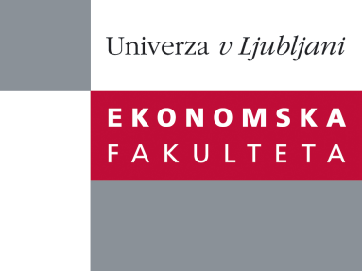

Raziskovalni center Ekonomske fakultete
organizira znanstveno - raziskovalni seminar,
ki bo v sredo, 23. novembra 2011, ob 12:00 uri
v P-109 na Ekonomski fakulteti v Ljubljani.

doc. dr. Mitja Kovač

(Univerza v Ljubljani, Ekonomska fakulteta)

bo predstavil članek:

"Unforeseen Contingencies in English and French Law – A Comparative Contract Law and Economics Perspective"

The problem of excuse for non performance of contracts caused by unforeseen contingencies has recently been the subject of increasing attention and intense scholarly debate. This paper offers an economic evaluation of the unforeseen contingencies phenomena and provides an economic assessment of the related provisions, decisions and doctrines. The main propositions and conclusions are the following: (1) optimal model rule provides a workable explanatory framework for distinguishing cases in which the promisor is excused from those where he is not; (2) efficiency requires granting under severe preconditions to a third party (judge) the power to adjust, discharge, or enforce a contract in case of excessively onerous performance; (3) compared legal systems differ less than comparatist’s tend to believe; (4) several landmark decisions might have been incorrectly interpreted; (5) the wealth maximization principle is identified as the main driving force behind judicial decision making; (6) a development pattern from less to more efficient rules and decisions is confirmed; (7) the problem of unforeseen contingencies should be seen as an ex post efficiency enhancing, welfare maximizing, and risk sharing mechanism; and finally (8) assessed provisions may be, from a scientific viewpoint, improved and elaborated further, where a path for statutory reform is obvious.

Na brezplačni seminar se lahko prijavite v Službi za znanstveno raziskovalno delo, po telefonu (01) 58-92-490, ali po e-pošti na naslov research.seminars@ef.uni-lj.si, in sicer do torka, 22.11.2011.
Vljudno vabljeni!

