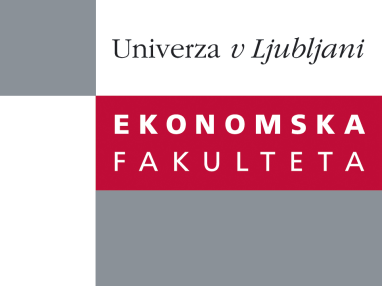
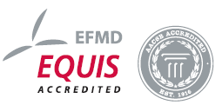

Raziskovalni center Ekonomske fakultete
organizira znanstveno - raziskovalni seminar,
ki bo v ponedeljek, 30. maja 2011, ob 14:00 uri
v klubski sobi CISEF-a na Ekonomski fakulteti v Ljubljani.

Prof. dr. Ingmar Björkman

(Hanken School of Economics, Helsinki, Finland)

bo predstavil raziskovalni projekt:
˝People Management in MNCs: Beyond the Integration-Responsiveness Framework”

Research on people management in MNCs has for a long time been dominated by a focus on the HRM practices implemented in foreign subsidiaries, often conceptualized in terms of the global integration-local responsiveness framework. In my presentation I will argue that we need go beyond this narrow focus to among others examining HRM in MNCs from a process perspective, studying the internalization of HRM by key actors, analyzing how employees perceive HRM practices, and investigating HRM antecedents of various employee outcomes. In my talk I will present findings from a multi-level study in Nordic MNCs in which we collected quantitative and qualitative data collected from corporate headquarters, MNCs units located in different parts of the world, and individual managers and professionals.

O predavatelju: Ingmar Björkman is Professor and Chair of the Department of Management and Organization at the Hanken School of Economics in Helsinki, Finland. Raised in Norway, he receiving his PhD from Hanken School of Economics after having done parts of his doctoral studies at Stanford University. Ingmar Björkman has been a visiting professor at Hong Kong University, ESSEC (Paris), and INSEAD (Fontainebleau and Singapore). He has also taught at a number of other business schools in Europe and Asia. ngmar Björkman’s research interests focus on people management issues in multinational corporations.. His research has been published in journals like Journal of International Business Studies, Journal of Management Studies, and Organization Studies. His latest books are Global Challenge: International Human Resource Management (second edition, 2011), co-authored with Paul Evans and Vlado Pucik, and Handbook of Research in International Resource Management (second edition, forthcoming), co-edited with Günter Stahl and Shad Morris. Ingmar is consulting editor of Management and Organization Review.
Na brezplačni seminar se lahko prijavite v pisarni RCEF po telefonu (01) 58-92-490, ali po e-pošti na naslov sodelavec.rcef@ef.uni-lj.si do petka, 27.05.2011.
Vljudno vabljeni!

