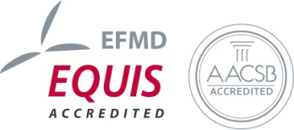
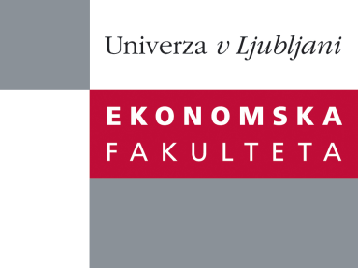

Raziskovalni center Ekonomske fakultete
organizira znanstveno - raziskovalni seminar,
ki bo v sredo, 30. novembra 2011, ob 12:00 uri
v P-109 na Ekonomski fakulteti v Ljubljani.

izr. prof.dr. Andreja Cirman

(Univerza v Ljubljani, Ekonomska fakulteta)

bo predstavila članek:

"Decisions to renovate: Identifying key determinants in transition countries"

Housing renovation is a topical issue in Central and Eastern European countries facing the need to improve energy efficiency and tackle their troubled post-war housing estates. This paper aims to shed light on the reasons the renovation of owner-occupied housing in the region is insufficient and examines factors impacting households’ renovation decisions in both single-family and multi-dwelling buildings. Building on the characteristics identified in the literature as common to housing renovation in CEE, Slovenia is used as an illustrative case. Considering factors recognised in the literature and specifically adding variables of social capital, a logit model of renovation decision-making is tested. Among the key predictors of renovation activity, locality and dwelling characteristics were confirmed; further, households’ socio-economic characteristics are found to be significant for the renovation of family houses, while in multi-dwelling buildings they are outweighed by social capital, denoting the attitudes and ability of residents to act collectively.

Na brezplačni seminar se lahko prijavite v Službi za znanstveno raziskovalno delo, po telefonu (01) 58-92-490, ali po e-pošti na naslov research.seminars@ef.uni-lj.si, in sicer do torka, 29.11.2011.
Vljudno vabljeni!

