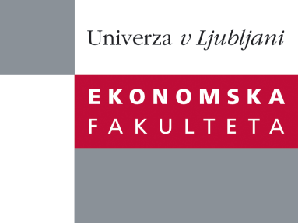

Raziskovalni center Ekonomske fakultete
organizira znanstveno - raziskovalni seminar,
ki bo v četrtek, 08. december 2011, ob 12:00 uri
v P-109 na Ekonomski fakulteti v Ljubljani.

dr. Mitja Pirc

bo predstavil članek:

"It matters how you pay: payment mechanism moderates the effect of price format on consumer behaviour and judgment"

"Managers are frequently faced with managing price changes towards consumers. Previous research has shown that consumer react differently if changes in costs are presented in an aggregated or segregated format, and that this effect is moderated by both product/service and consumer characteristics. Given the economic nature of firm-customer relationship there is always (at least one) payment mechanism present. We propose that payment mechanism moderates the effect of cost format on consumer behavior and judgment; furthermore the dynamic exposure of the payment mechanism outweighs the static effects of product/service and/or customer characteristics. Support is found through three studies: field experiment in metro commuting, controlled experiment in skiing and a field study in telecommunications. These results have clear implications for practice, in particular firms can learn from the way consumers pay, how they should manage consumer cost changes."

Na brezplačni seminar se lahko prijavite v Službi za znanstveno raziskovalno delo, po telefonu (01) 58-92-490, ali po e-pošti na naslov research.seminars@ef.uni-lj.si, in sicer do srede, 07.12.2011.
Vljudno vabljeni!

