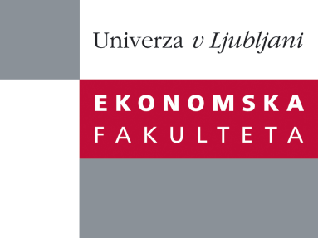

Raziskovalni center Ekonomske fakultete
organizira znanstveno - raziskovalni seminar,
ki bo v petek, 13. maja 2011, ob 14:00 uri
v klubski sobi CISEF-a na Ekonomski fakulteti v Ljubljani.

Prof. dr. Gyewan Moon

(School of Business Administration Kyungpook National University, Daegu, S. Korea)

bo predstavil članek:
˝Effective implementation of communities of practices (CoPs) in a knowledge habitat: a case illustration˝

It is critical for an organization to acknowledge, nurture, and utilize the potential pool of knowledge that resides in individuals and teams. Although communities of practices (CoPs) have been recognized as an effective vehicle for taking advantage of explicit and tacit knowledge within an organization, little is known about factors that facilitate and impede their birth and growth. Accordingly, this study provides a research framework that organizes and manages CoPs in a knowledge habitat. In addition, it illustrates the usefulness of the research framework by conducting a case study at Samsung Electronics. Management implications are also discussed.

O predavatelju: Gyewan Moon is Full Professor at the School of Business Administration Kyungpook National University, Daegu, S. Korea. He received his research doctorate degree in 1996 in Southern Illinois University at Carbondale, U.S.A. with dissertation titled: Speed of recovery: Effects of organizational and industrial variables on rate of recovery in turnarounds. He has also taught at a number of other business schools in Europe, Asia and USA. Gyewan Moon has research interests focus on strategic management issues and organization theory. His research has been published in journals like Journal of Management Education, International Journal of Services & Operations Management, Journal of Human Resource Management, Korean Journal of Business Administration, etc.

Na brezplačni seminar se lahko prijavite v pisarni RCEF po telefonu (01) 58-92-490, ali po e-pošti na naslov sodelavec.rcef@ef.uni-lj.si do četrtka, 12.05.2011.
Vljudno vabljeni!

