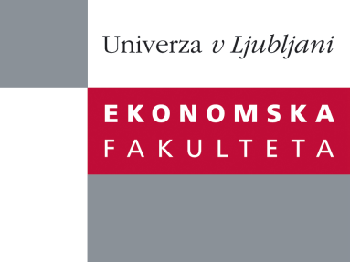

Raziskovalni center Ekonomske fakultete
organizira znanstveno - raziskovalni seminar,
ki bo v četrtek, 07. julija 2011, ob 10:00 uri
v sejni sobi CISEF-a na Ekonomski fakulteti v Ljubljani.

Alexander Josiassen, PhD

(School of Hospitality, Tourism and Marketing Victoria University-Australia)

bo predstavil članek, ki je bil objavljen v Journal of Marketing:
˝Consumer Disidentification and Its Effects on Domestic Product Purchases: An Empirical Test in the Netherlands˝

Consumers’ local bias is an important determinant of domestic product purchase behavior. Consumer ethnocentrism refers to consumers’ tendency to prefer domestic products and avoid foreign products. Researchers and marketing managers investigate levels of consumer ethnocentrism to ascertain the level of local biases in the market place. This research asserts that such an approach provides an incomplete picture at best, and seeks to provide a more comprehensive understanding of domestic product biases. The article introduces the concept of consumer disidentification to reflect negative domestic biases. The article also develops a framework which integrates consumer ethnocentrism, consumer disidentification, consumer affinity, and consumer animosity in the country attraction-repulsion matrix. The framework helps predict consumers’ dispositional responses to local and foreign products. The consumer ethnocentrism-disidentification model regarding domestic product purchases is tested using survey data from 1534 second-generation immigrants who were born in, and live in, the Netherlands. Structural equation modeling supports the model and shows that consumer disidentification has a significant impact on buying decisions above and beyond the effect of consumer ethnocentrism. Results further show that for second-generation Turkish immigrants acculturation and ethnic identification are important predictors of both consumer ethnocentrism and consumer disidentification. There are several implications of this research. More implications are discussed in the article.

Na brezplačni seminar se lahko prijavite v pisarni RCEF po telefonu (01) 58-92-490, ali po e-pošti na naslov sodelavec.rcef@ef.uni-lj.si do srede, 06.07.2011.
Vljudno vabljeni!

