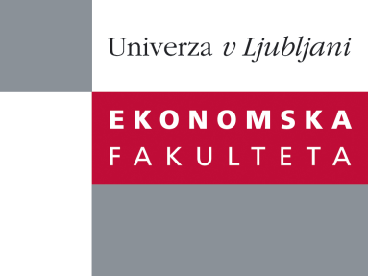

Raziskovalni center Ekonomske fakultete
organizira znanstveno - raziskovalni seminar,
ki bo v sredo, 11. Septembra 2013, ob 12:00 uri
v P-109 na Ekonomski fakulteti v Ljubljani.

Predstavljen bo članek:

“Perceived Expected Return (PER) and Perceived Risk (PR): Behavioral Biases”

avtor: prof. Chris Veld, University of Glasgow; dr. Guy Kaplanski, Bar-Ilan University, prof. Haim Levy and prof. Yulia Veld-Merkoulova, University of Glasgow

˝Surveying investors in the stock market, we explore whether past realized rates of return (RR) affect the perceived reward-to-risk Sharpe ratio (PSR). We find two phenomena that contribute to autocorrelations in stock returns. First, in both the domestic and international markets weekly RR are positively correlated with short- and long-term PSR and this correlation can be explained by adjustment to changes in market risk. Second, domestic daily RR are positively correlated with both domestic and international short-term PSR. The short-term phenomenon, the direction from the domestic market toward the international market and the fact that it is significantly more profound in male subjects and tends to be more profound in bullish market all support the argument for a behavioral bias.”

Na brezplačni seminar se lahko prijavite v Službi za znanstveno raziskovalno delo, po telefonu (01) 58-92-490, ali po e-pošti research.seminars@ef.uni-lj.si, in sicer do torka, 10.9.2013.

Vljudno vabljeni!

