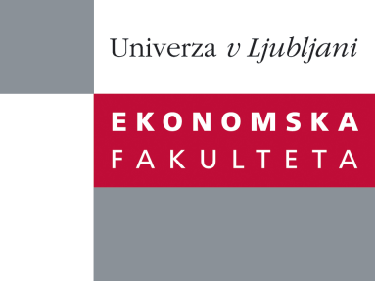

Raziskovalni center Ekonomske fakultete
organizira znanstveno - raziskovalni seminar,
ki bo v sredo, 19. marca 2014, ob 12:00 uri
v P-109 na Ekonomski fakulteti v Ljubljani.

Predstavljen bo članek:

“How Does Bank Trading Activity Affect Performance? An Investigation Before and After the Crisis”

avtor: prof. dr. Nadia Massoud, York University, Kanada
(soavtorji: prof. dr. Michael R. King, University of Western, Kanada
prof. dr. Keke Song, Dalhousie University, Kanada)

˝The current debate on the impact of proposed rules to ban or limit proprietary trading activities (e.g. Volcker Rule, Vickers and Liikanen reports) has motivated us to examine whether the exposure of U.S. bank holding companies (BHCs) to trading assets has an adverse impact on their risk, profitability and stock return. The literature provides conflicting evidence on how diversifying into different business lines may affect a BHC’s performance. We examine three measures of a BHC’s trading activity: the share of trading revenues in operating income, the share of trading assets in total assets, and the market share of trading assets across all BHCs. We find that a BHC’s trading activities are positively correlated with its riskiness and negatively correlated with profitability and stock returns, especially during and after the 2007-2009 crisis. These results hold when we control for changes in traditional lending activities and off-balance-sheet activities. Additionally, we find that BHCs with a higher market share of trading assets make a greater contribution to systemic risk. These results suggest that limiting proprietary trading may improve BHC performance while reducing systemic risk, especially during economic downturns.˝

Na brezplačni seminar se lahko prijavite v Službi za znanstveno raziskovalno delo, po telefonu (01) 58-92-490, ali po e-pošti research.seminars@ef.uni-lj.si, in sicer do torka, 18.3.2014.
Vljudno vabljeni!

